 

**Placement Empowerment Program**

***Cloud Computing and DevOps Centre***

**Set up a virtual machine in the cloud** : Create a free tier azure account .Launch a virtual machine and ssh into it.

Name: Subiksha R Department: AML



**Introduction :**

Virtual machines (VMs) are essential components in cloud computing, enabling users to run applications and operating systems in isolated environments. They eliminate the need for physical hardware while providing flexibility, scalability, and control over computing resources. Microsoft Azure, a leading cloud platform, offers powerful tools for deploying and managing VMs efficiently.

Creating a virtual machine in Azure helps users gain hands-on experience in cloud infrastructure management, understand resource allocation, and securely connect to remote environments using protocols like Remote Desktop Protocol (RDP) and Secure Shell (SSH).

**Overview :**

This task focuses on using the Azure portal to create and configure a virtual machine from scratch. The process includes selecting a resource group, operating system, VM size, and networking configuration while ensuring secure access through user authentication methods.

Key steps include:

1. Logging into the Azure portal.
2. Configuring VM properties such as region, OS, and disk type.
3. Setting up secure access through RDP or SSH.
4. Managing network security groups for inbound/outbound traffic.
5. Testing connectivity and managing resources.

Upon completion, you will have a fully functional virtual machine capable of hosting applications and services.

**Objective :**

1. **Understand Cloud Computing Concepts:** Learn the role of virtual machines in cloud infrastructure.
2. **Navigate the Azure Portal:** Develop familiarity with Azure tools and services.
3. **Create a Virtual Machine:** Configure essential components such as region, image, and size.
4. **Secure Access:** Use RDP or SSH to establish secure remote connections.
5. **Resource Management:** Understand resource groups, storage, and network configurations.
6. **Develop Practical Skills:** Gain real-world experience in deploying and managing cloud infrastructure.

This task prepares you for advanced roles in cloud administration, development, and IT operations.

**Step-by-Step procedure :**

**STEP 1 :** Login to Azure Portal

* Go to <https://portal.azure.com>.

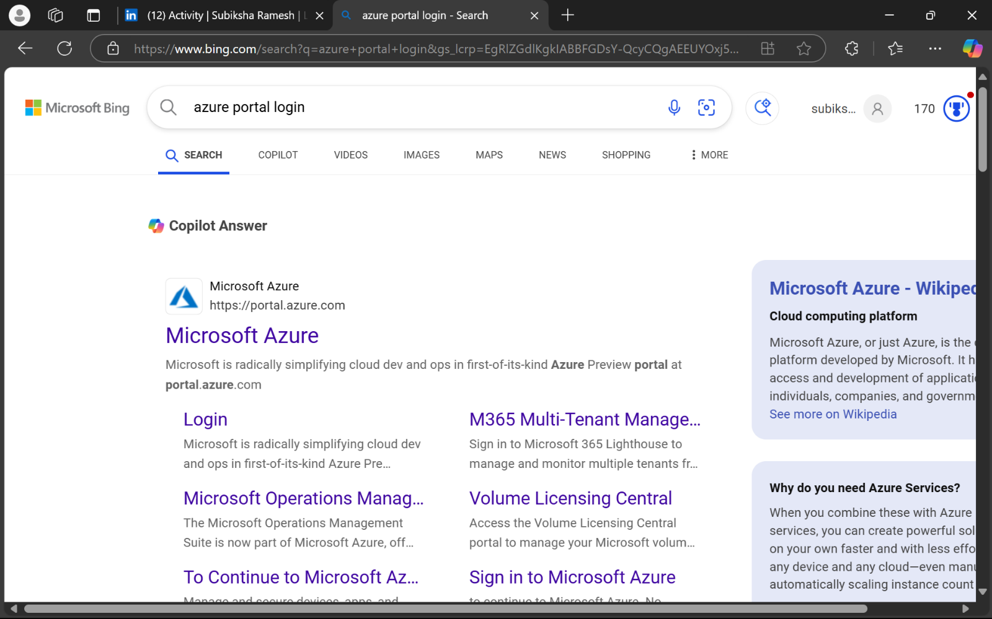

**STEP 2 :** Choose the account in which you want to login.

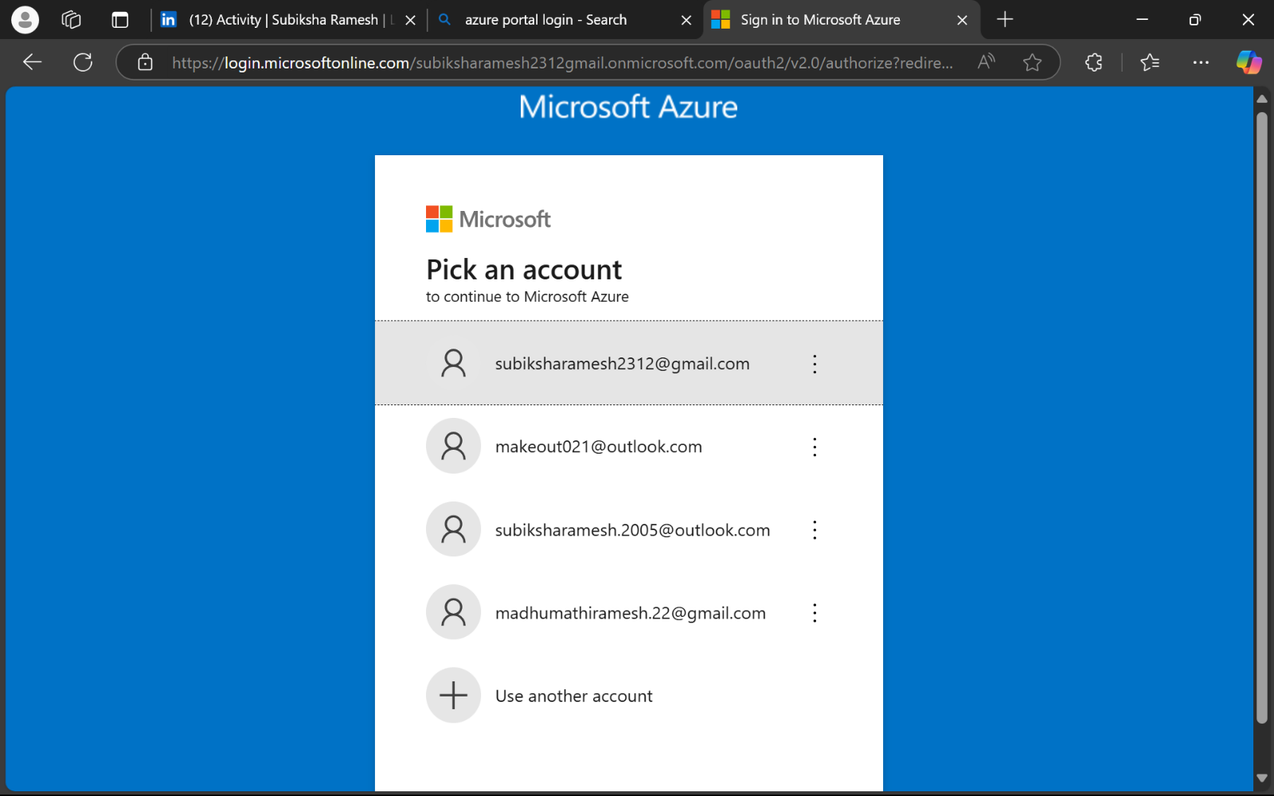

**STEP 3 :** Once logged in, you’ll see the Azure Portal dashboard.

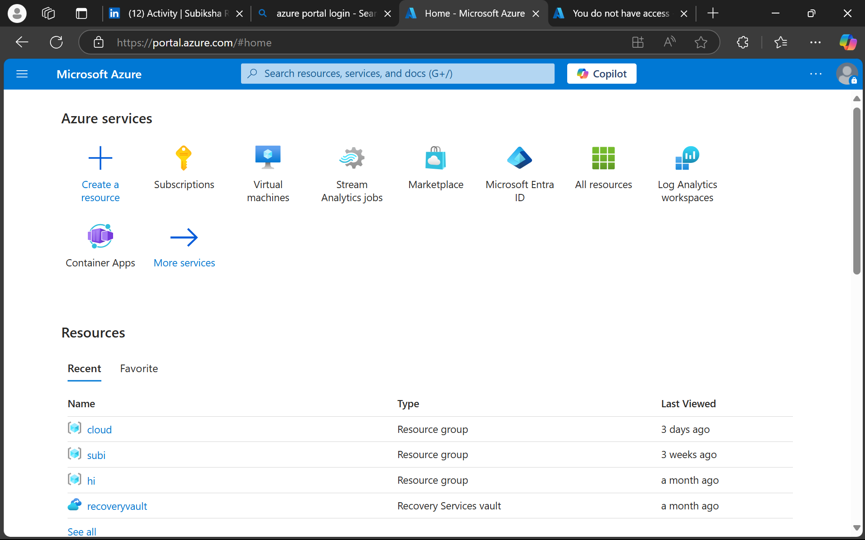

**STEP 4 :** In the search bar at the top, type Virtual Machines and select it from the dropdown list.

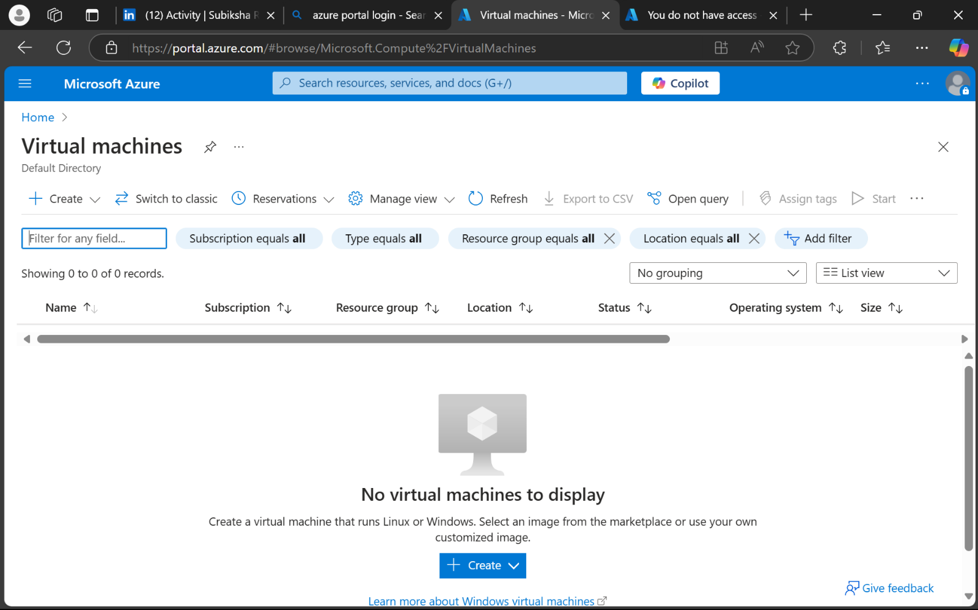

**STEP 5 :**

* Click the + Create > Azure Virtual Machine button.
* **Configure Basic Settings.**
* **Subscription:** Select the appropriate subscription.
* **Resource Group:** Choose an existing resource group or click **Create new** to make one.
* **Virtual Machine Name:** Enter a name for your VM (e.g., MyVM).
* **Region:** Select a region (choose the one closest to you).
* **Availability Options:** Select as needed (default is usually sufficient).
* **Image:** Select the operating system (e.g., Windows Server 2022, Ubuntu 20.04 LTS).
* **Size:** Click **Change size** and choose an appropriate machine size (Standard_B1s for light tasks).

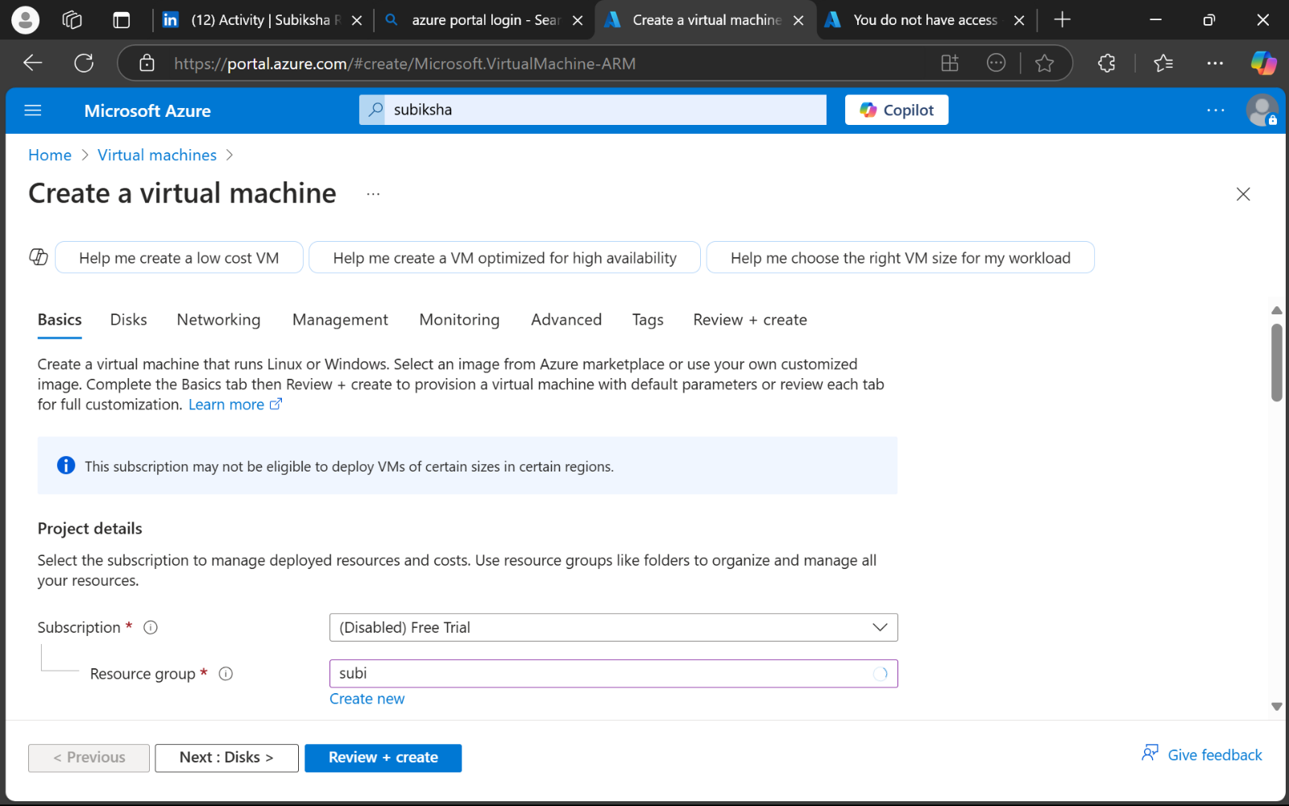

**STEP 7 :**

* Authentication Type:
* Select Password or SSH Public Key.
* Provide a Username and set a strong Password if using password-based authentication.
* Inbound Port Rules: Ensure RDP (3389) is selected for Windows VMs and SSH (22) for Linux VMs.

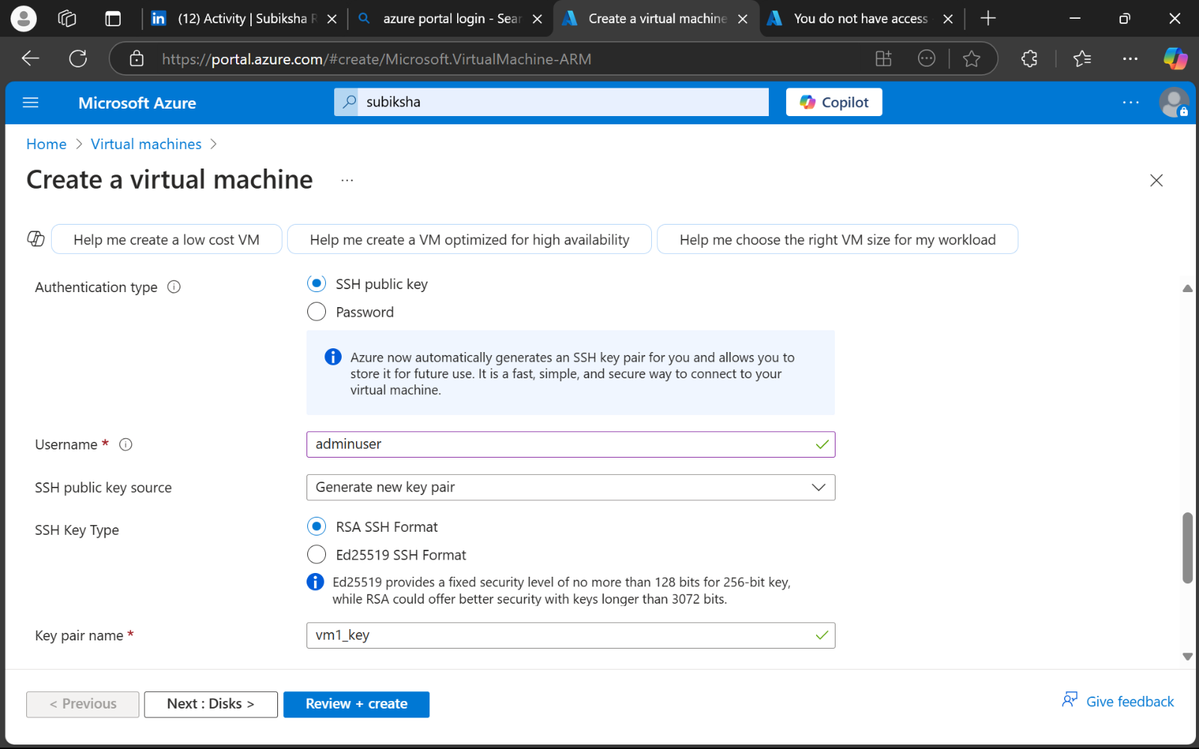

**STEP 8 : Configure Networking**

* Ensure a Virtual Network and Public IP are automaticall

configured.

* Check that Allow selected ports includes RDP for Windows or SSH for Linux.

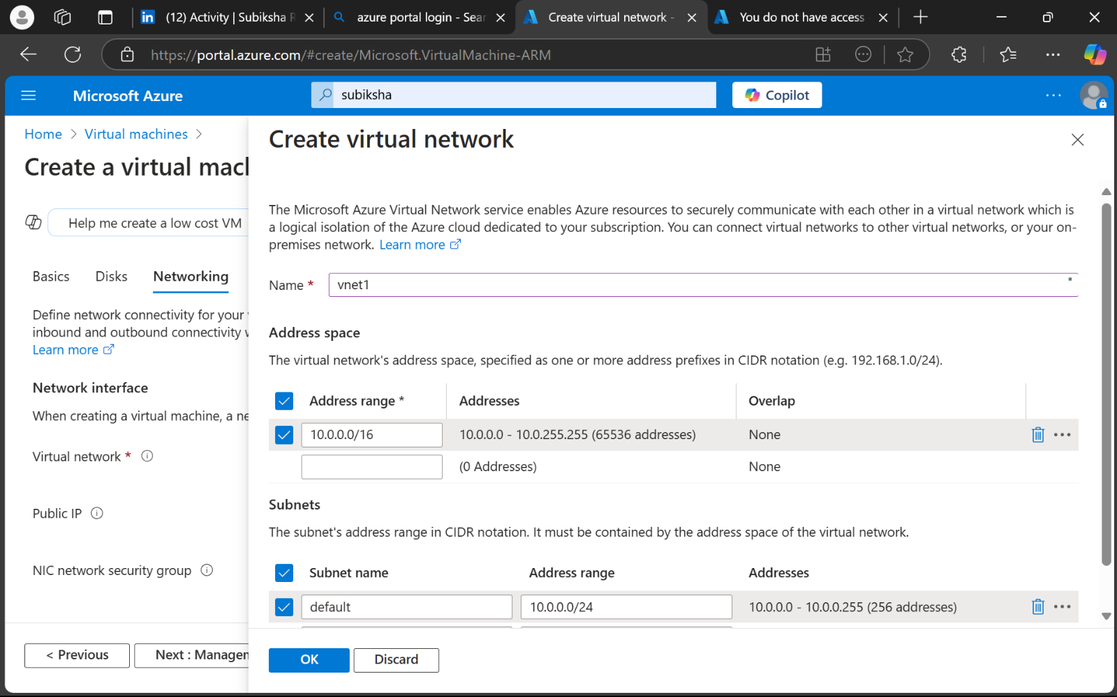

**STEP 9 : Review and Create.**

* Click **Review + Create**.
* Azure will validate your settings.
* If validation passes, click **Create**.

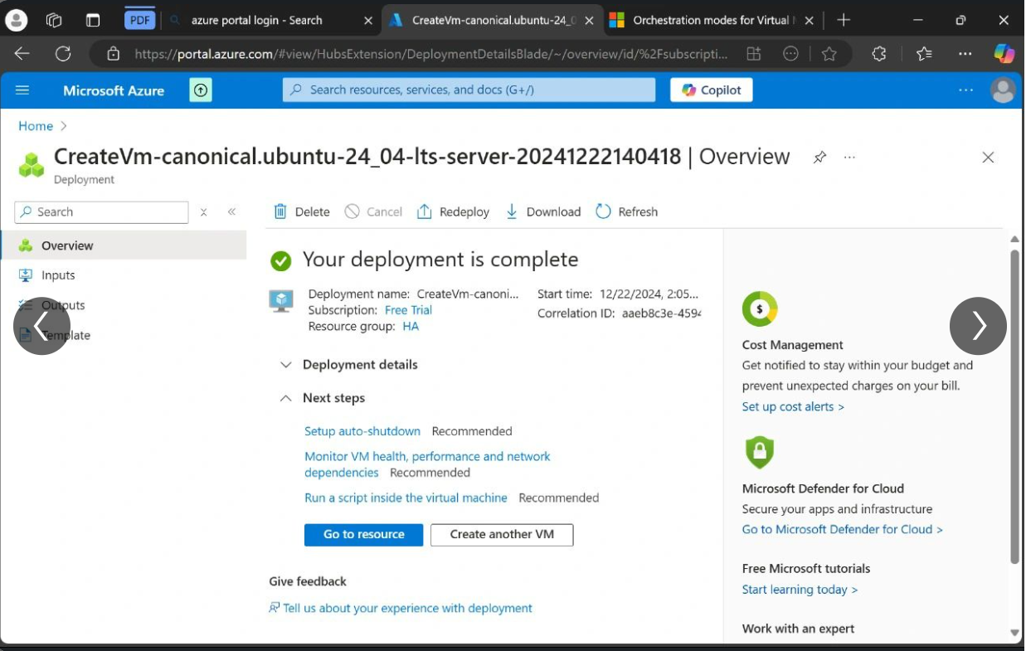

**STEP 10 : Deployment**

* Wait for the deployment process to complete.
* Once completed, click **Go to Resource**.

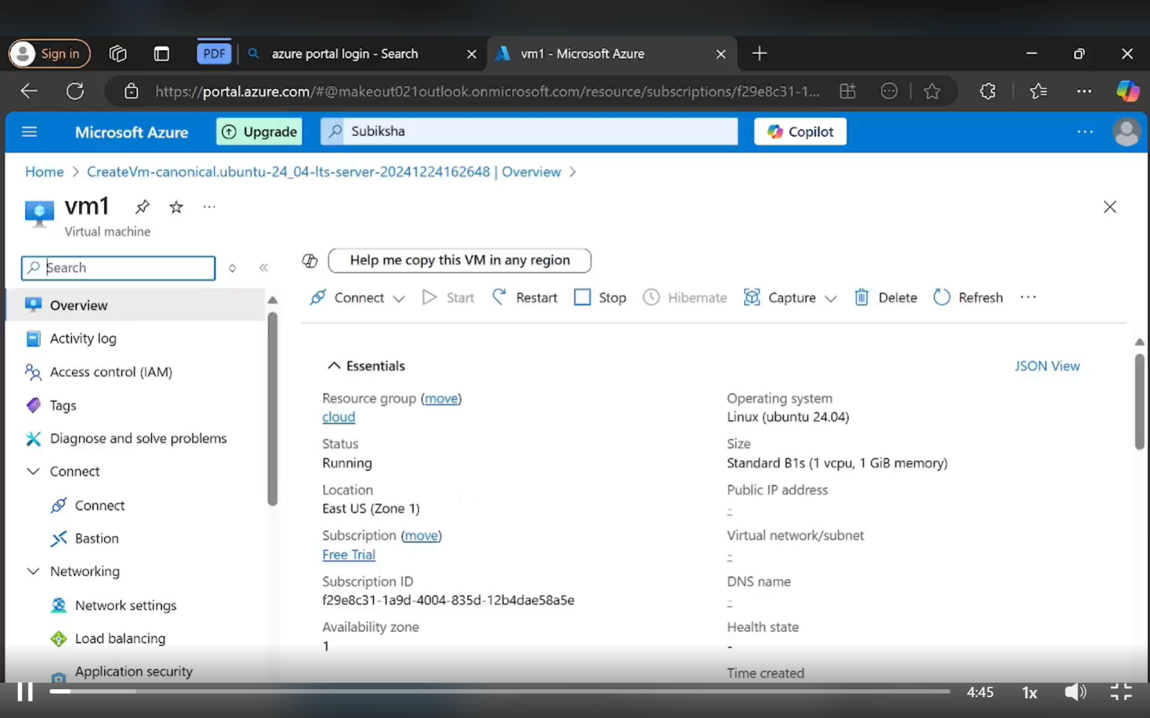

**STEP 11 : Download and Open the RDP File.**

* Click the **Connect** button at the top menu, and choose **RDP**.
* Under **RDP Configuration**, click **Download RDP File**.
* Save the file to your system.

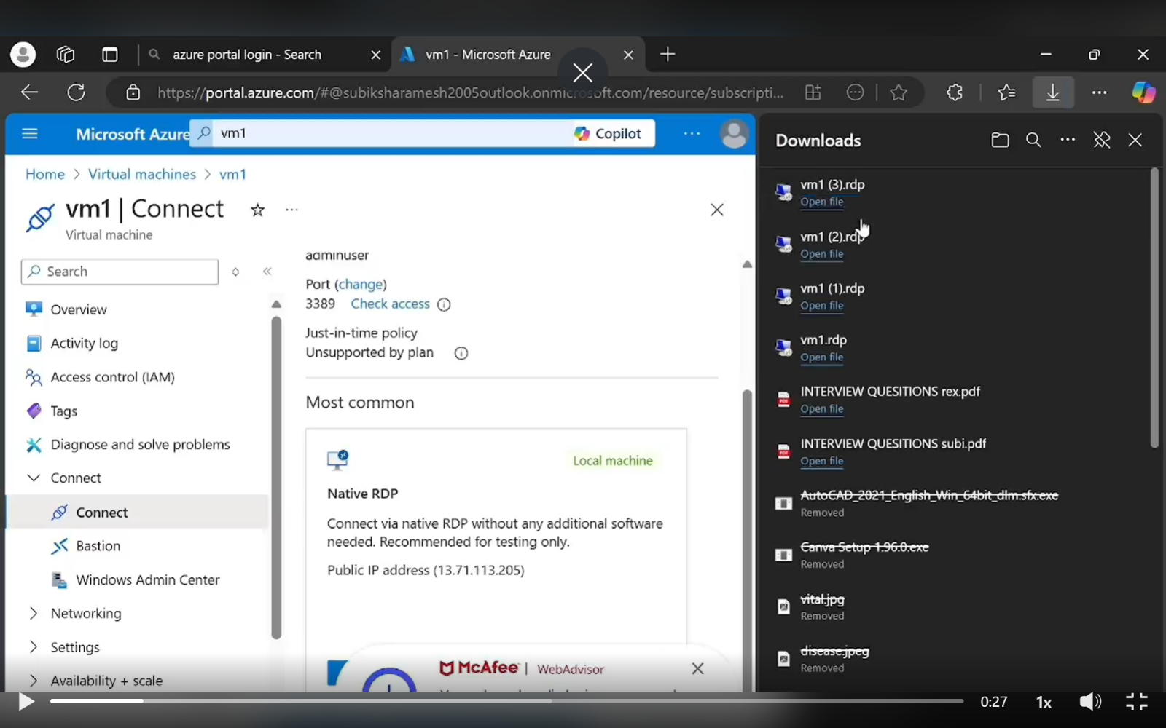

**STEP 12 : Connect to the Virtual Machine.**

* Locate and double-click the downloaded RDP file.
* A prompt will appear; click **Connect**.

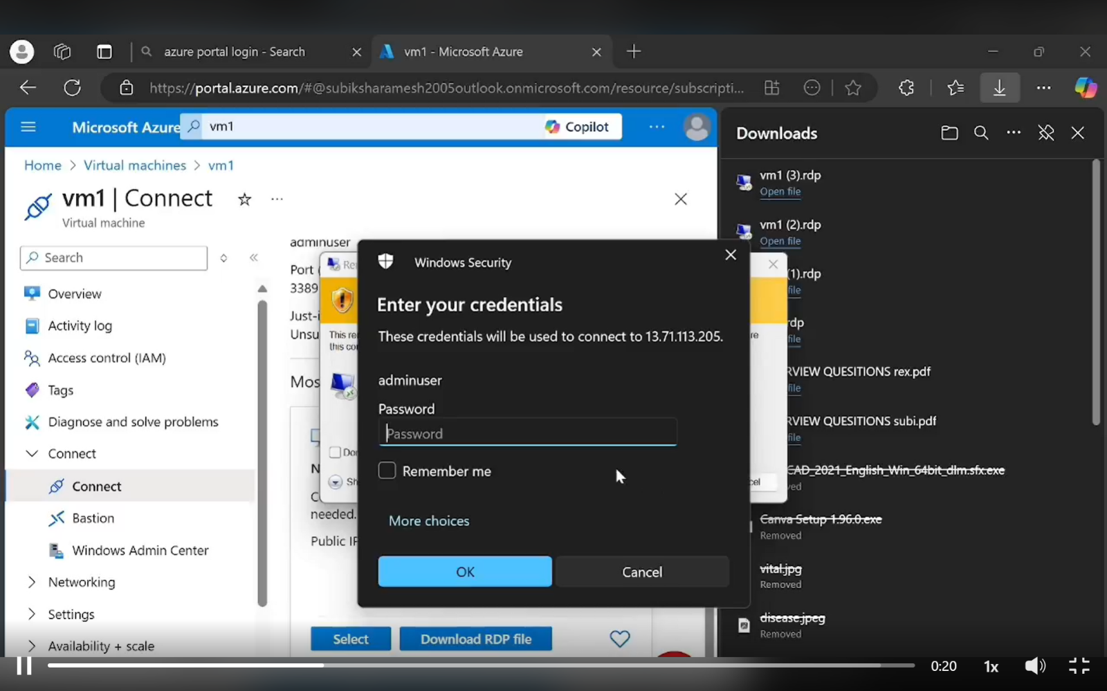

**STEP 13 : Enter Login Credentials.**

* Provide the VM's **Username** and **Password** you set during VM creation.
* Click **OK**.

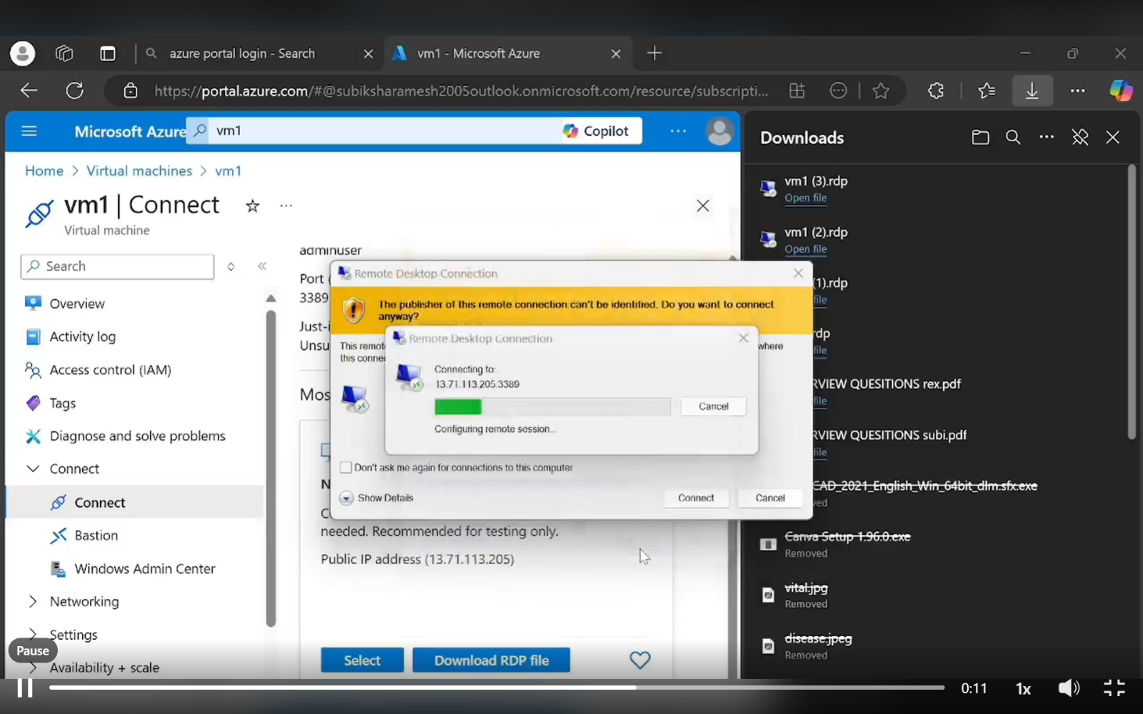

**STEP 14 : Accept Security Warning.**

* A certificate warning may appear.
* Select **Don’t ask me again for connections to this computer** (if trusted).
* Click **Yes**.

**STEP 15 : Control the Remote Desktop**

* You will now be connected to the desktop environment of your Azure virtual machine.

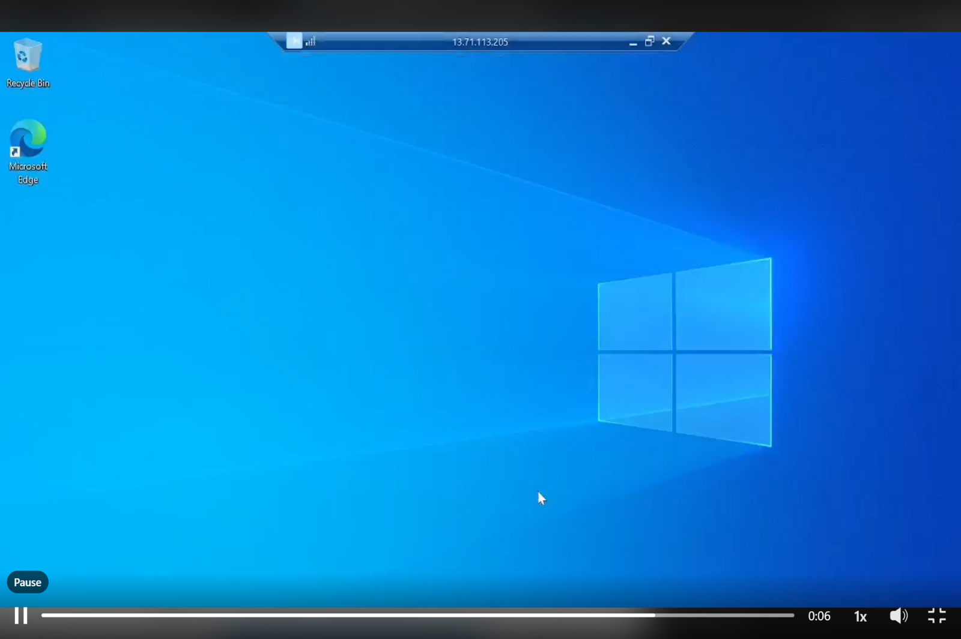

**Outcome :**

1. Hands-on Experience with Azure Portal

* Familiarity with navigating the Azure Portal and its key components.
* Understanding resource groups and virtual network configurations.

2. Successful Creation of a Virtual Machine (VM)

* Deployment of a functional virtual machine with the selected operating system and hardware configurations.

3. Secure Connection to VM

* Establishing secure remote connections via Remote Desktop Protocol (RDP) for Windows or Secure Shell (SSH) for Linux.

4. Resource and Security Configuration

* Understanding and applying inbound/outbound traffic rules using Network Security Groups (NSG).
* Efficient allocation and monitoring of cloud resources.

5. Improved Problem-Solving Skills

* Ability to troubleshoot common connectivity issues and adjust security settings as required.

6. Practical Cloud Infrastructure Knowledge

* Insight into deploying scalable IT environments in cloud infrastructure.
* Readiness for advanced tasks involving server hosting, cloud-based applications, and system automation.

This task provides foundational skills necessary for future work in cloud services, IT administration, and software deployment environments.